**Summary of Related Works**

The prediction of student performance using machine learning techniques has been widely explored, with researchers applying various algorithms and datasets to achieve optimal results. Below is a summary of key related works:

**Classification and Prediction of Student Performance Data Using Various Machine Learning Algorithms (UCI Student Dataset)**  
Researchers used Support Vector Machines (SVM), Naïve Bayes, C4.5, and ID3 to classify student performance. SVM demonstrated the highest accuracy of 88% for the UCI Student Performance dataset, making it an efficient tool for classification tasks [1].

**Students’ Performance Prediction Using KNN and Naïve Bayesian**  
This study used attributes like gender, secondary school name, and parents' occupation for predicting student performance in Gaza Strip. It was concluded that Naïve Bayes outperformed KNN in terms of prediction accuracy [2].

**Student Performance Analysis System (SPAS)**  
Researchers implemented algorithms such as J-48, CART, BF-Tree, and Random Tree to analyze quizzes, assignments, and examination grades at the University of Malaysia Sarawak. BF-Tree provided the best results for accurate predictions [4].

**Analysis and Prediction of Student Academic Performance Using Machine Learning**  
Using Kaggle datasets, this study applied supervised linear regression and deep learning-based linear regression techniques. The results showed that supervised linear regression offered better accuracy than deep learning models [5].

**A Comparative Study to Predict Student Performance Using Educational Data Mining Techniques**  
Naïve Bayes and Decision Tree classifiers were applied to predict student performance in Indonesia. The study concluded that Naïve Bayes performed better in classifying and predicting student success rates [6].

**Prediction of Students’ Performance Using Educational Data Mining**  
This work utilized 19 attributes, including demographic and academic factors, with Naïve Bayes as the primary algorithm. The model was implemented at Amrita School of Arts & Science, achieving high classification accuracy [7].

**Using Machine Learning Models to Predict Student Retention**  
A state-wide early warning system was developed using 15 attributes from administrative data. Logistic Regression, Naïve Bayes, and Decision Trees were tested, achieving an 80% success rate in identifying at-risk students [8].

These studies highlight the effectiveness of machine learning algorithms such as SVM, Naïve Bayes, and Decision Trees in predicting student performance. The choice of datasets, feature selection methods, and algorithms significantly impacts accuracy. These works provide a foundation for using advanced methods like feature selection (e.g., Boruta) and ensemble models to improve performance prediction further.

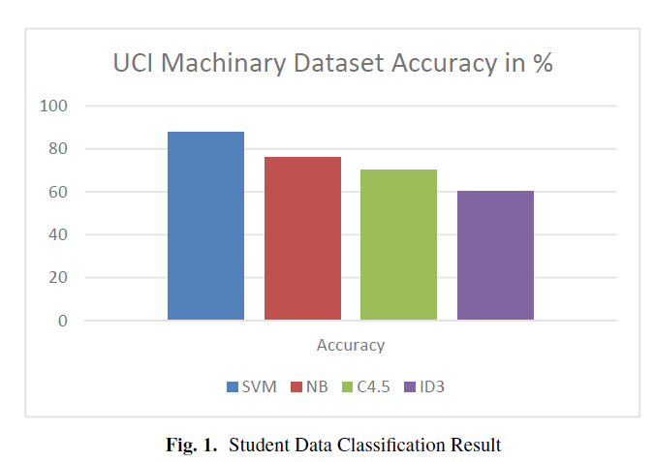  
  
This chart illustrates the classification accuracy of different machine learning algorithms (SVM, Naïve Bayes, C4.5, and ID3) when applied to the UCI Machinery Student Dataset. Here's a summary of the results:

* **Support Vector Machine (SVM)**: Achieved the highest accuracy at approximately 88%, making it the most effective algorithm among the evaluated methods for this dataset.
* **Naïve Bayes (NB)**: Performed second-best, with an accuracy slightly below SVM.
* **C4.5 and ID3**: These decision tree-based algorithms displayed moderate accuracy, trailing behind both SVM and NB.

**References**

1. UCI Machine Learning Repository: Student Performance Dataset.
2. Gaza Strip Student Performance Prediction.
3. University of Malaysia Sarawak, SPAS Model.
4. Kaggle Dataset: Predicting Academic Performance.
5. Industrial Engineering University, Indonesia Study.
6. Amrita School of Arts & Science Performance Prediction.
7. State-wide Early Warning System for At-Risk Students.